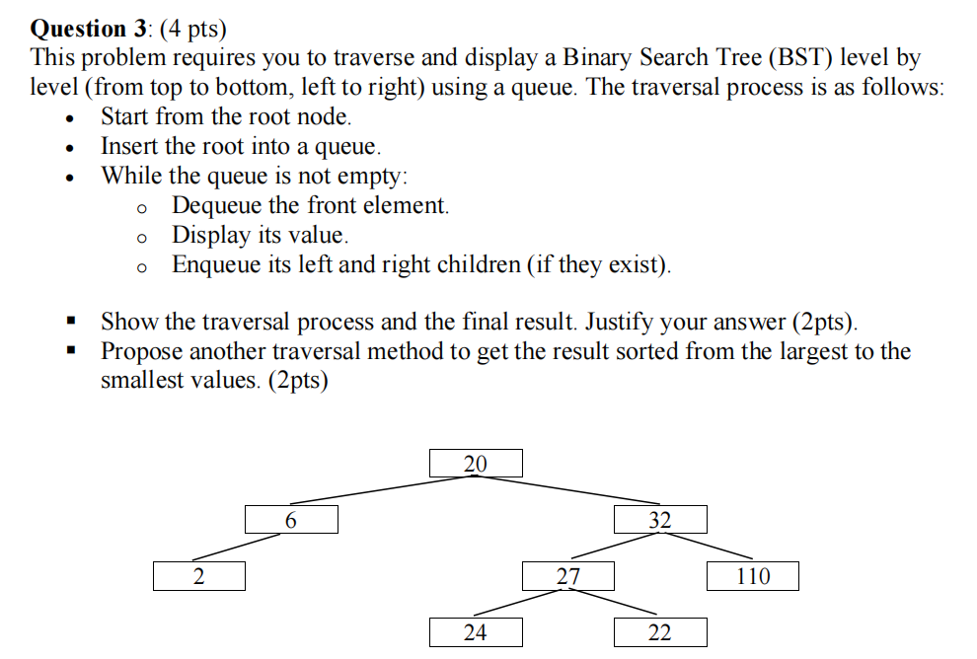

Start at 20
Dequeue(20)
Print(20)
queue(6, 32)

Start 6
De 6
Print 6
Queue(32, 2)

Start 32
De 32
Print 32
Queue(2, 27, 110)

Start 2
De 2
Print 2
Queue(27, 110)

Start 27
De 27
Print 27
Queue(110, 24, 22)

Start 110
De 110
Print 110
Queue(24, 22)

Print 24 , 22

20 6 32 2 27 110 24 22

